**MongoDB Assignment 3**

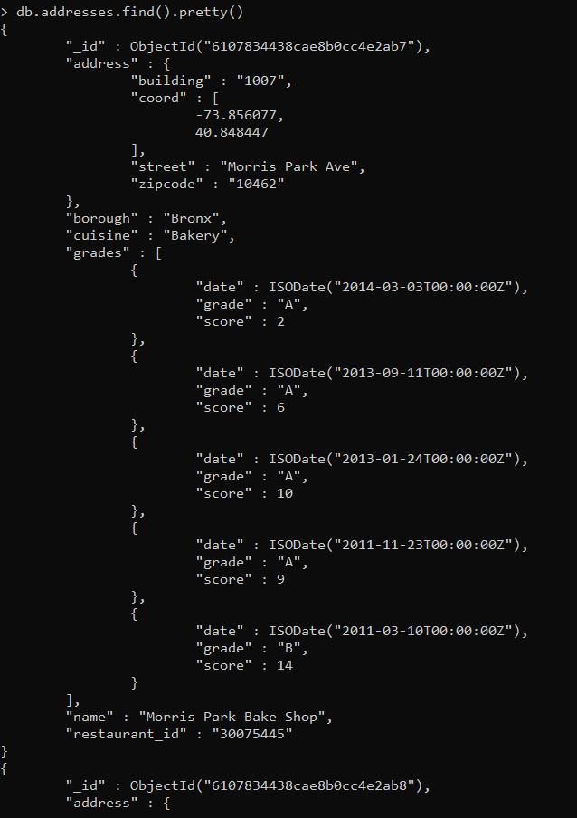**1.**

2.

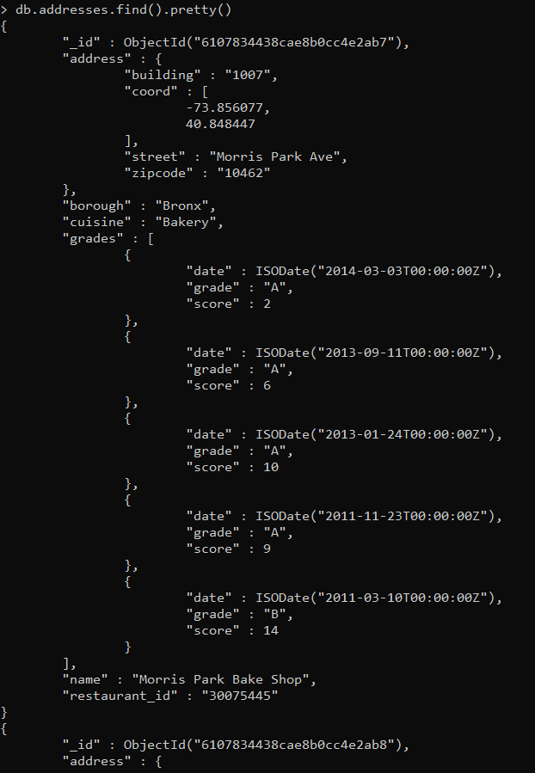

**3.**

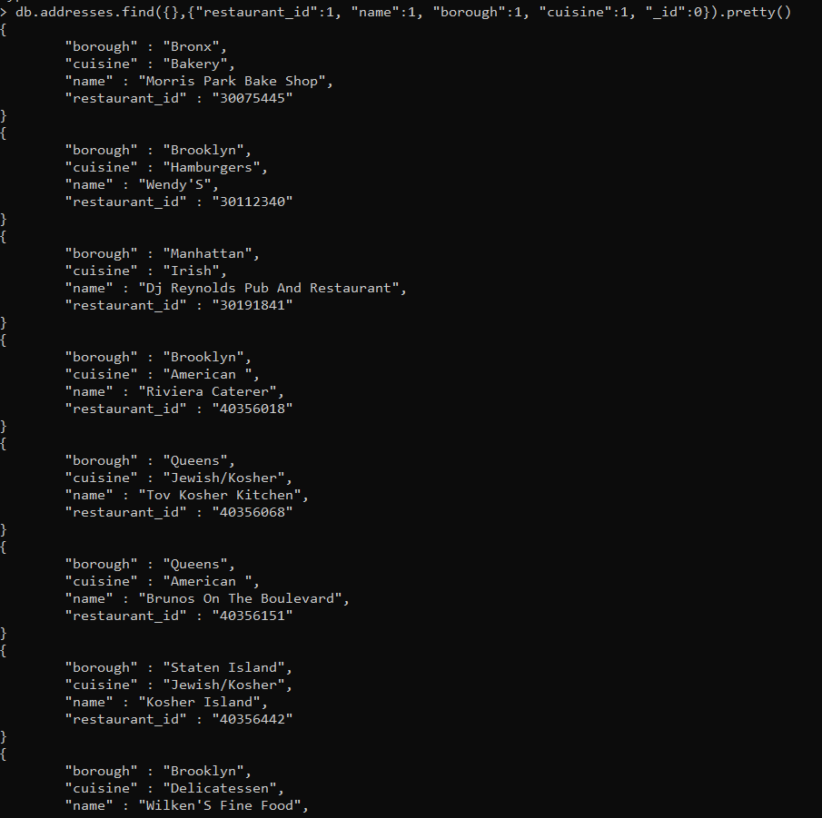

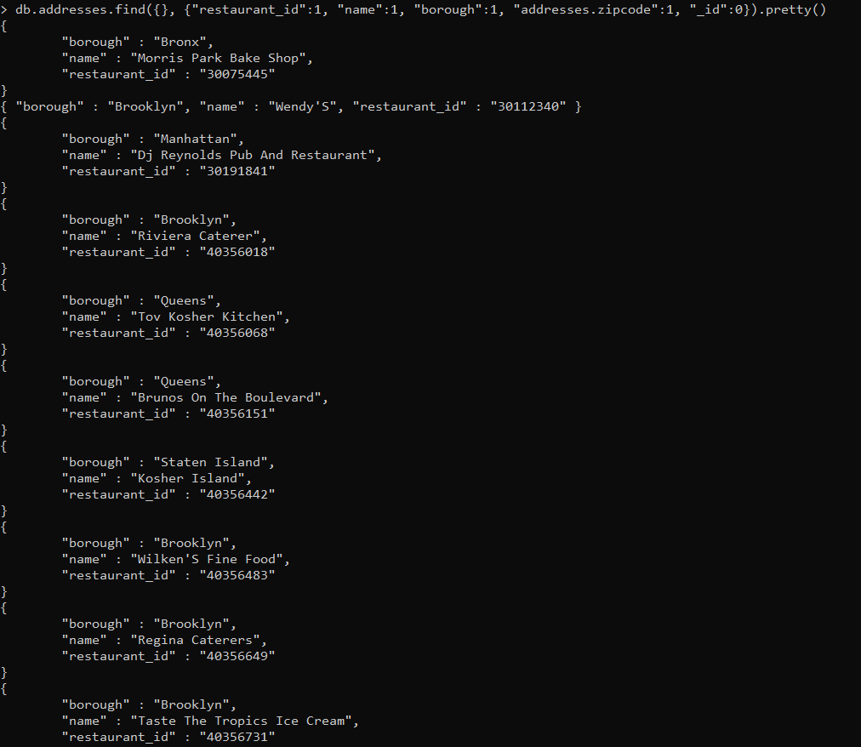**4.**

**5.**

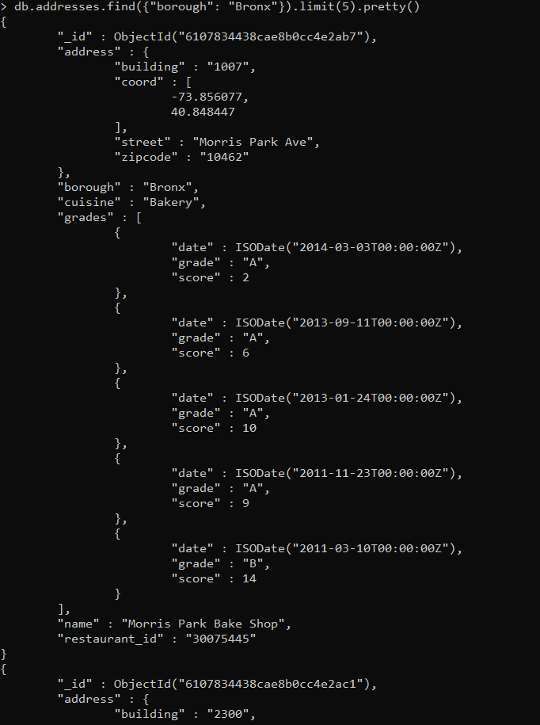

**6.**

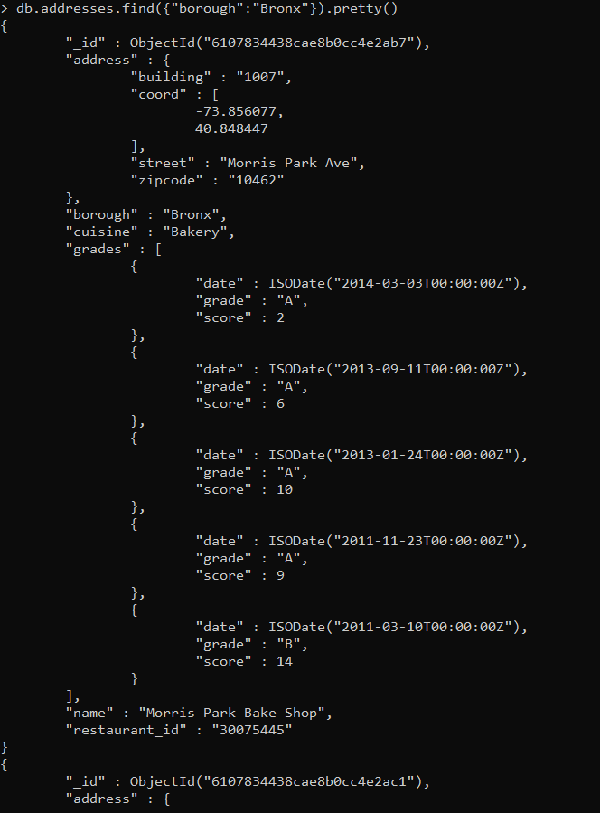

**7.**

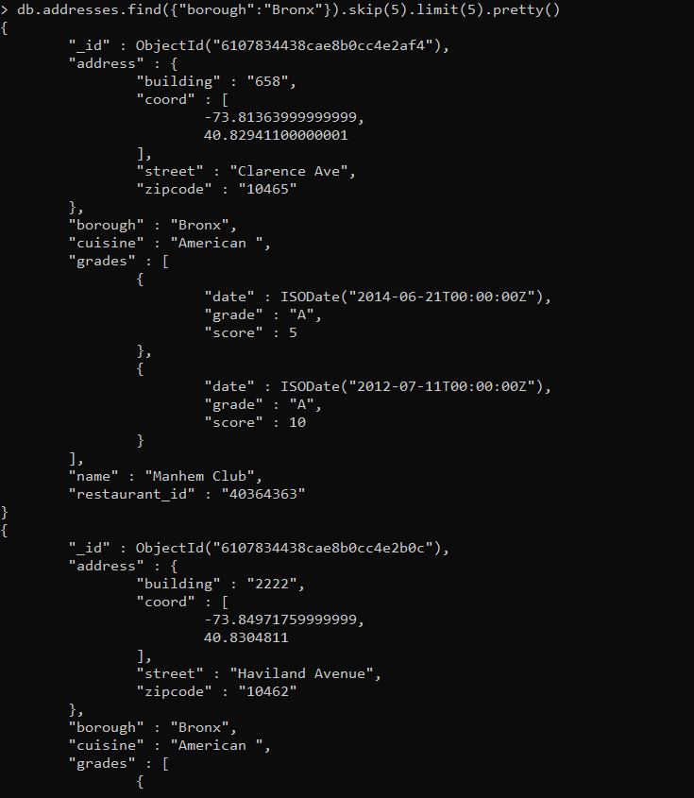

**8.**

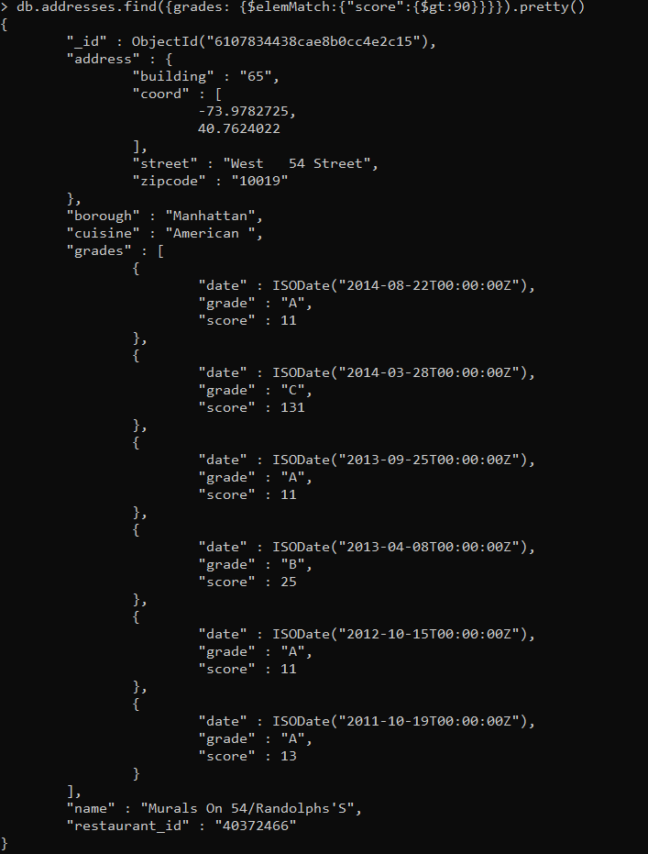

**9.**

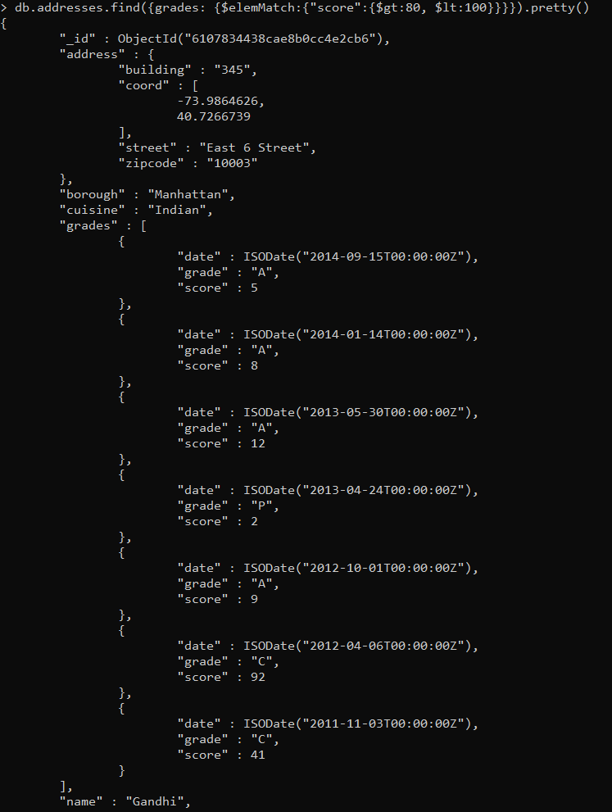

**10.**

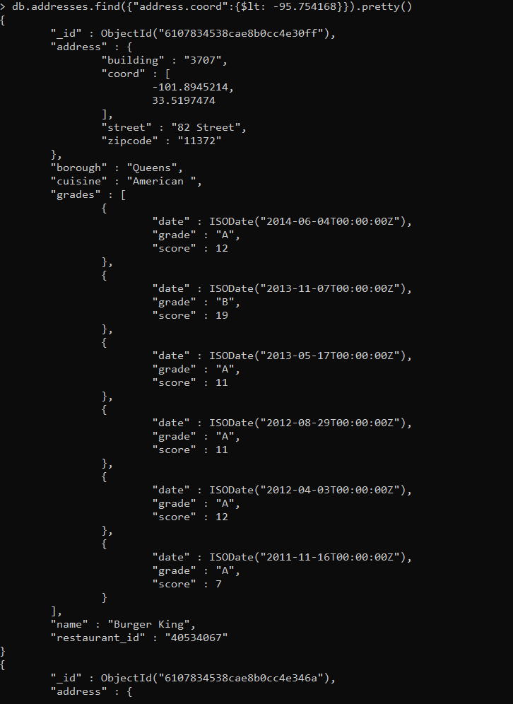

**11.**

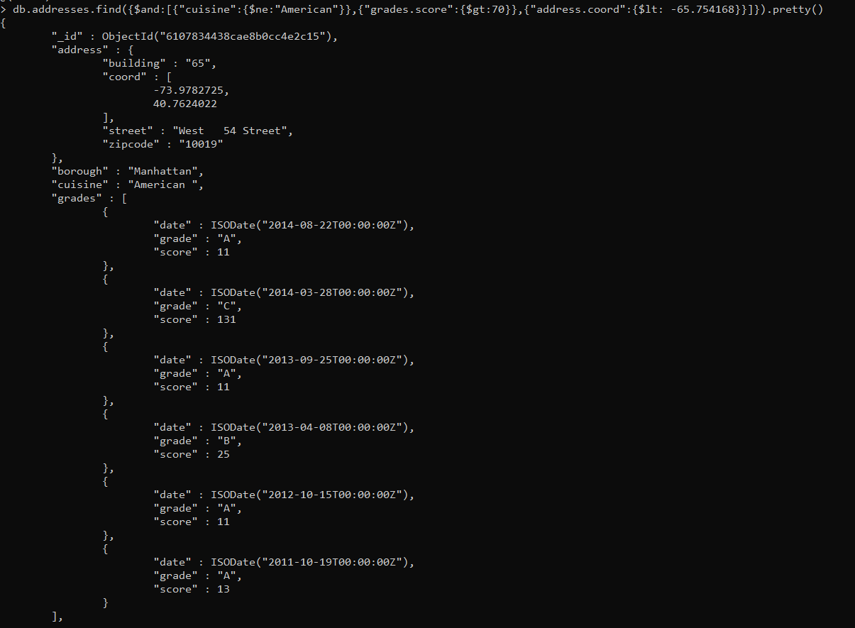

**12.**

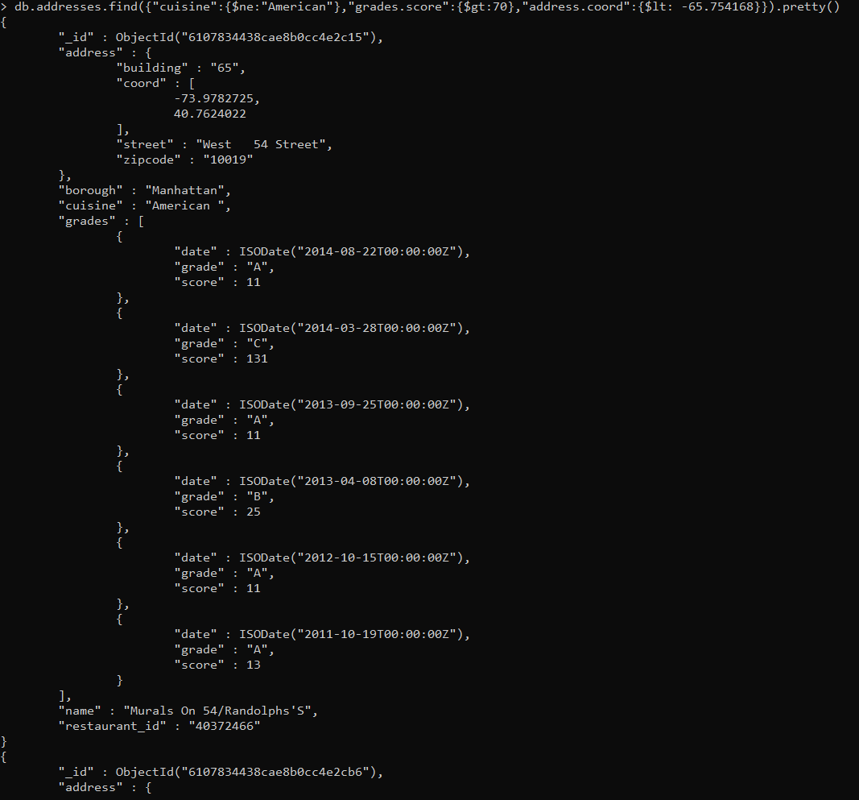

**13.**

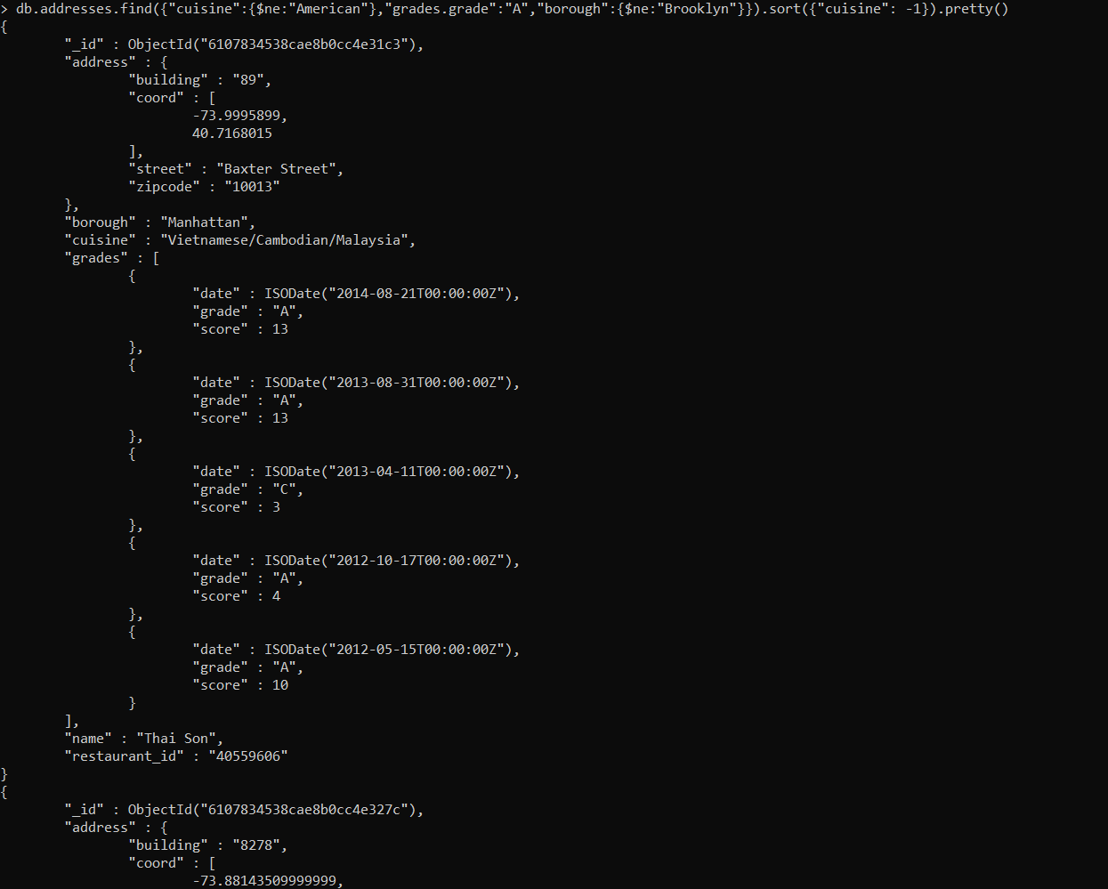

**14.**

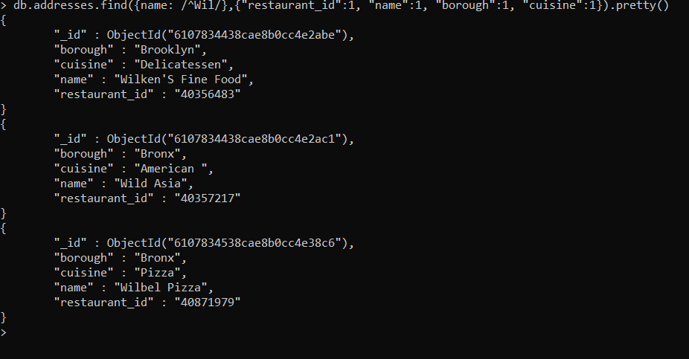

**15.**

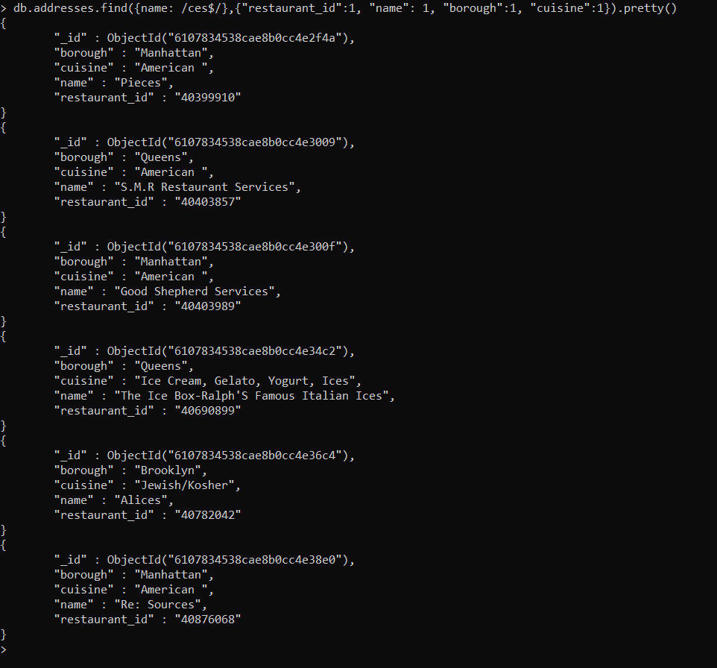

**16.**

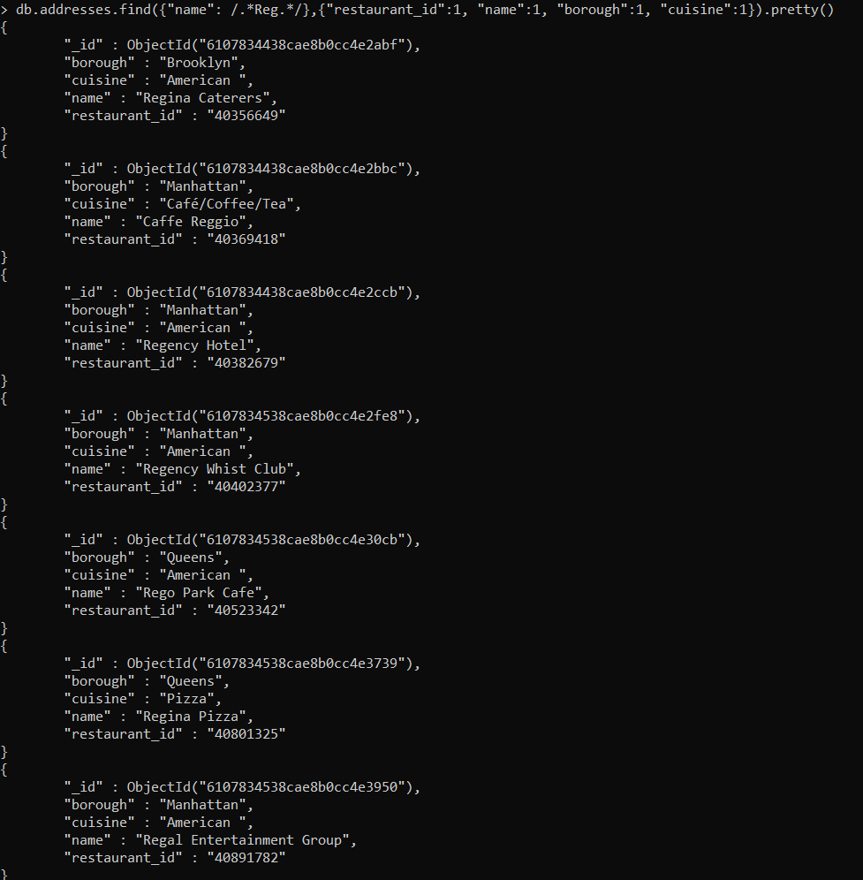

**17.**

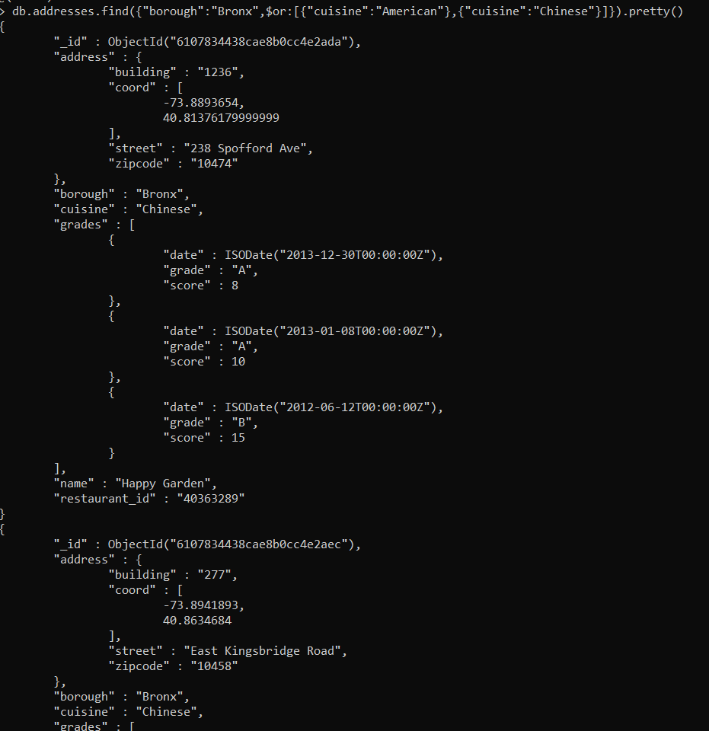

**18.**

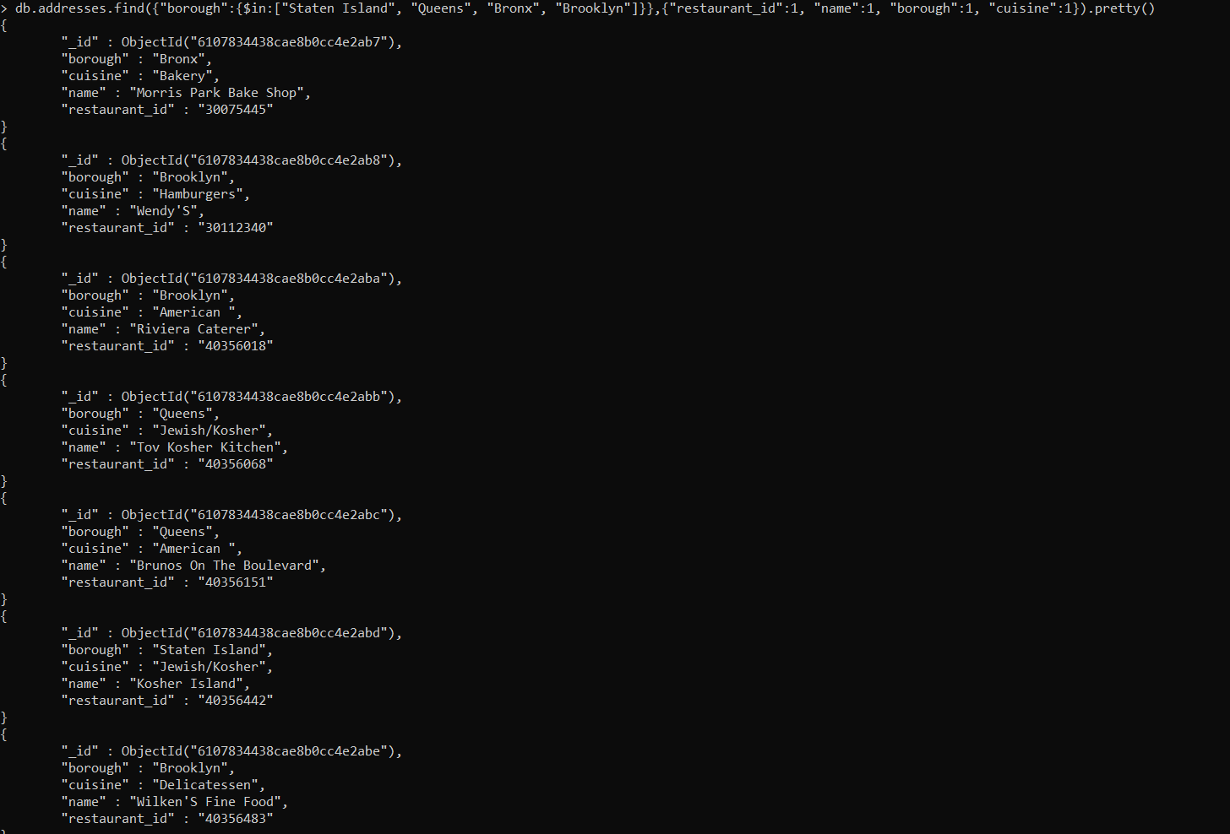

**19.**

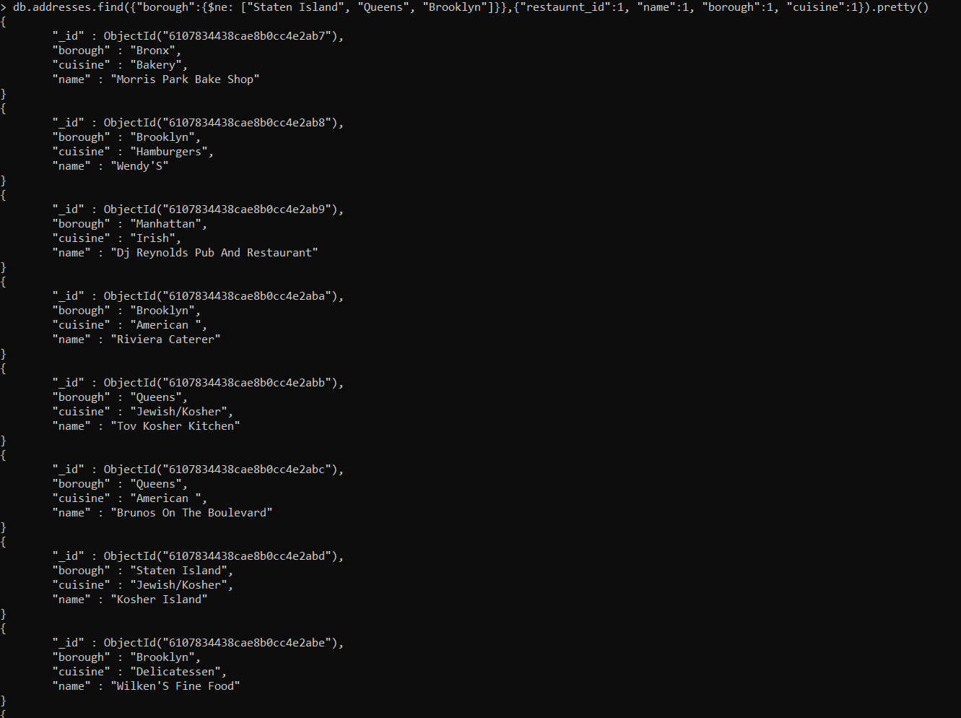

**20.**

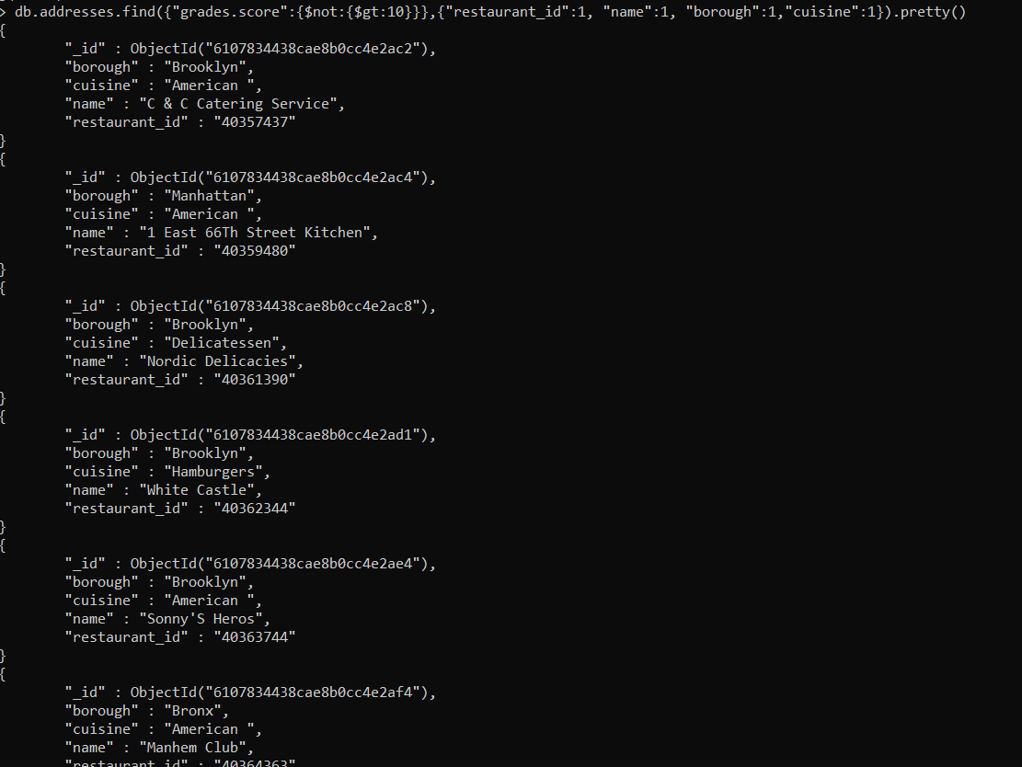

**21**.

db.addresses.find({$or:[{name:/^Wil/},{"$and":[{"cuisine":{$ne:"American"}},{"cuisine":{$ne:"Chinees"}}]}]}).pretty()

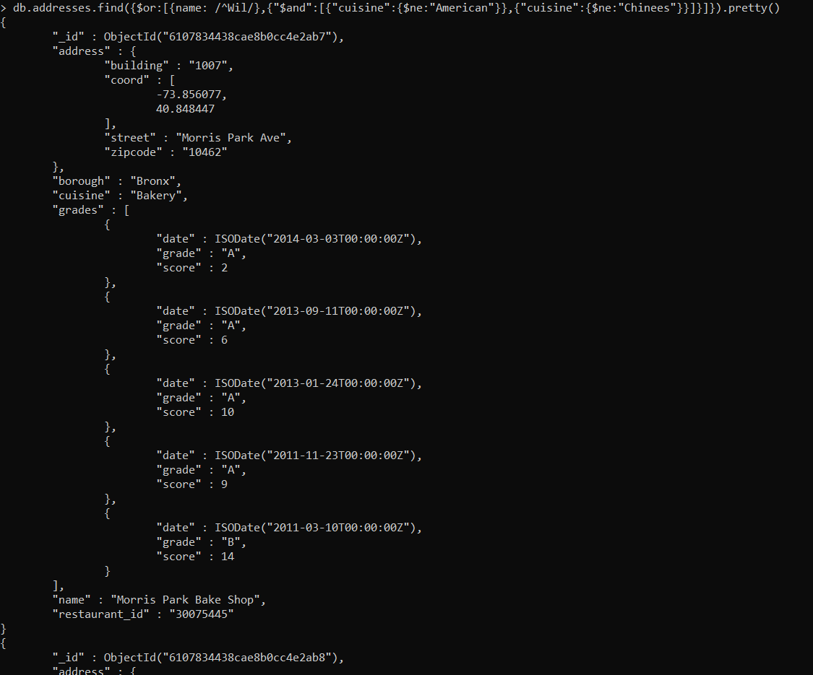

**22.**

db.addresses.find({"grades.date":ISODate("2014-08-11T00:00:00Z"),"grades.1.grade":"A","grades.1.score":9},{"restaurant_id":1,"name":1,"grades":1}).pretty()

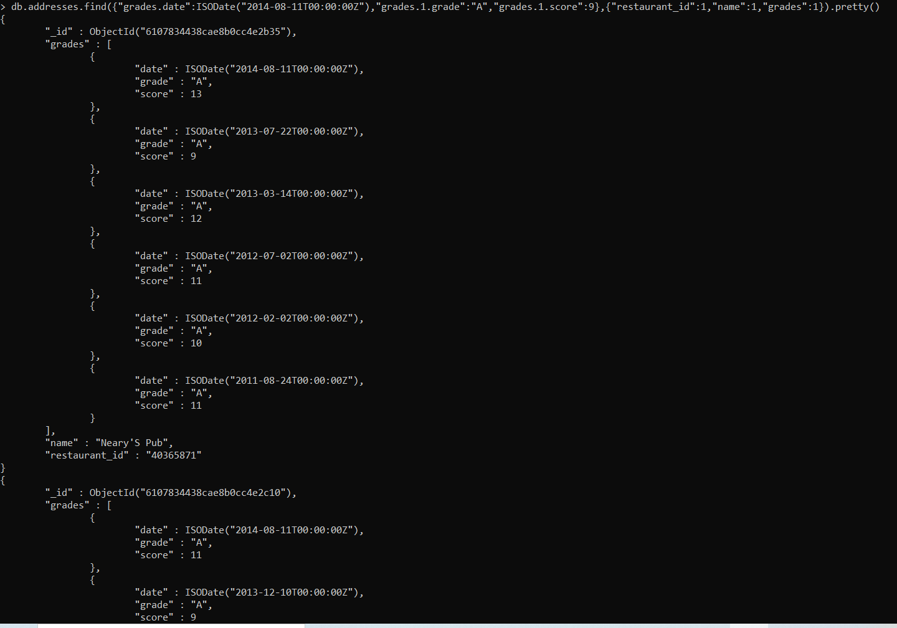

**23.**

db.addresses.find({"grades.1.date":ISODate("2014-08-11T00:00:00Z"),"grades.1.grade":"A", "grades.1.score":9},{"restaurant_id":1, "name":1 , "grades":1}).pretty()

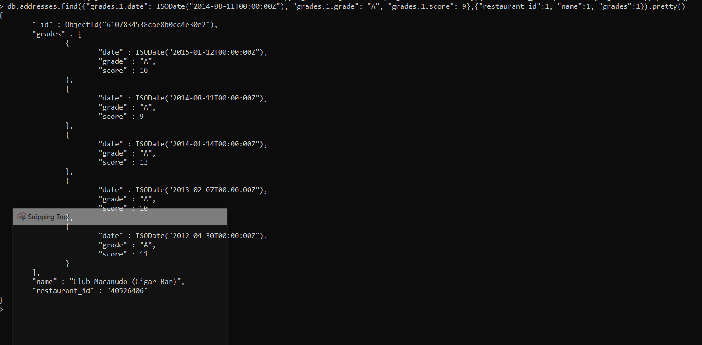

**24.**

db.addresses.find({"address.coord.1":{$gt:42, $lte: 52}},{"restaurant_id":1, "name":1, "address":1, "coord":1}).pretty()

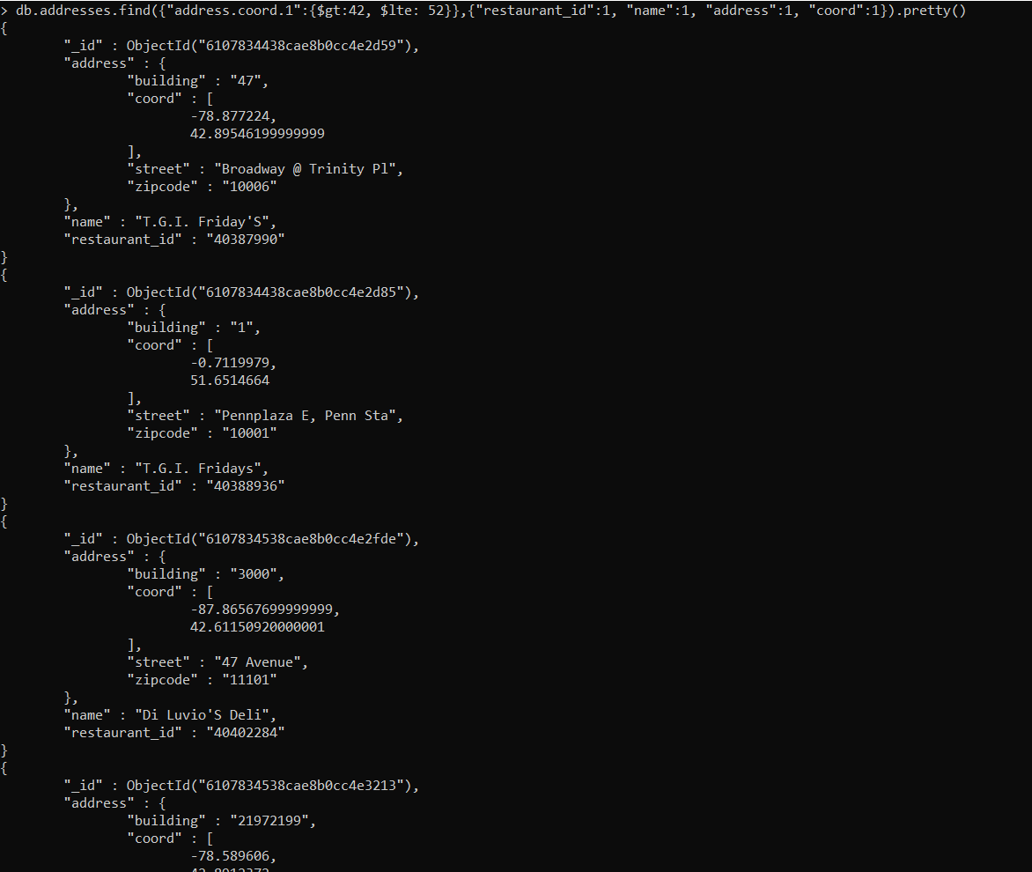

**25.**

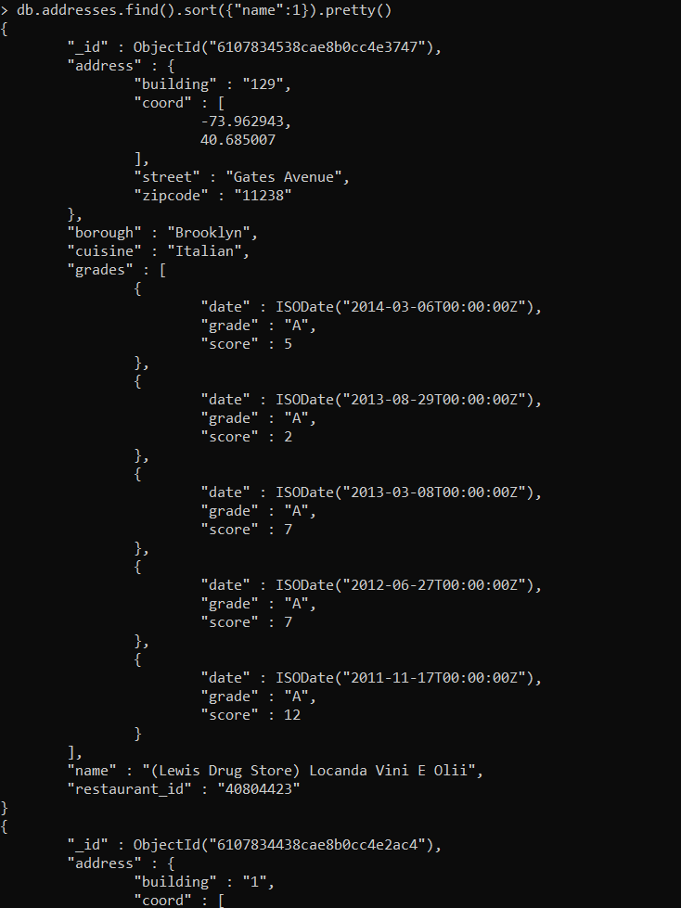

**26.**

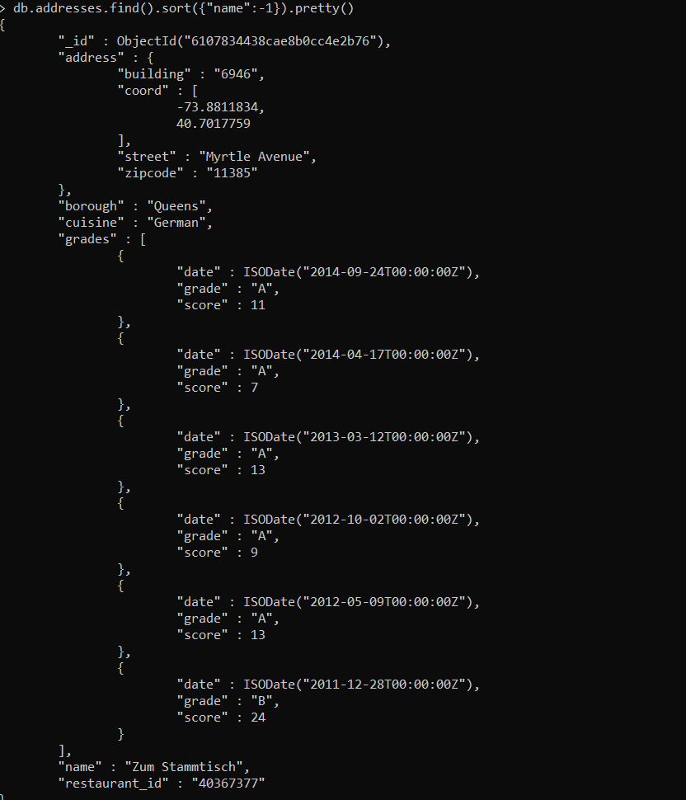

**27.**

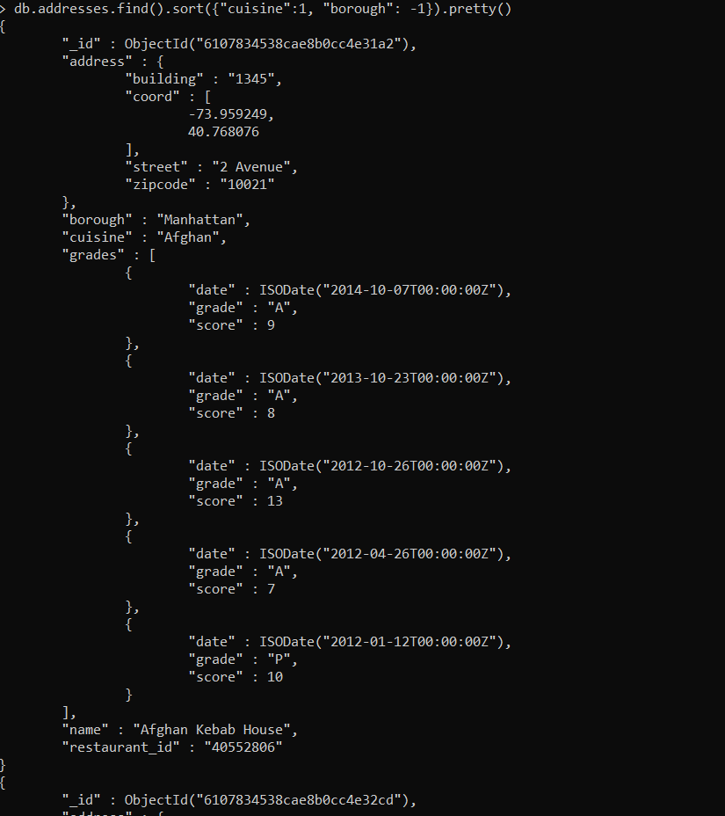

**28.**

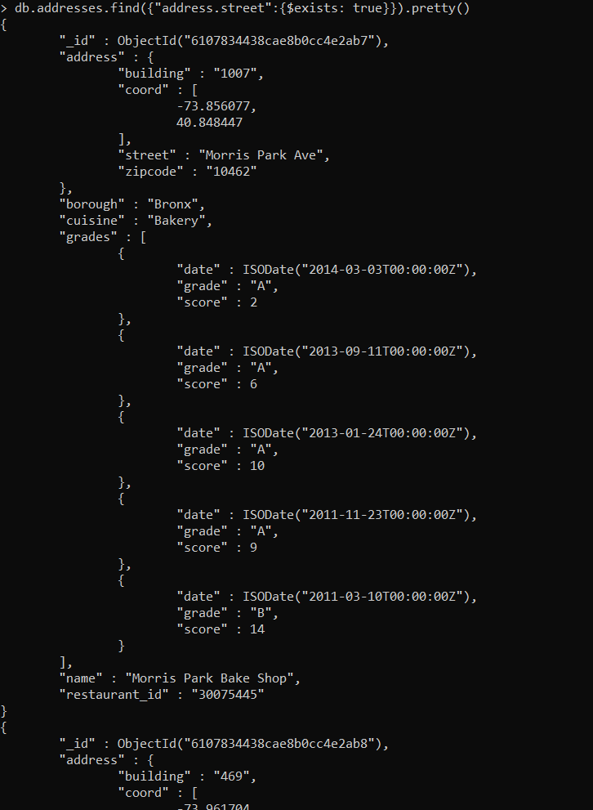

**29.**

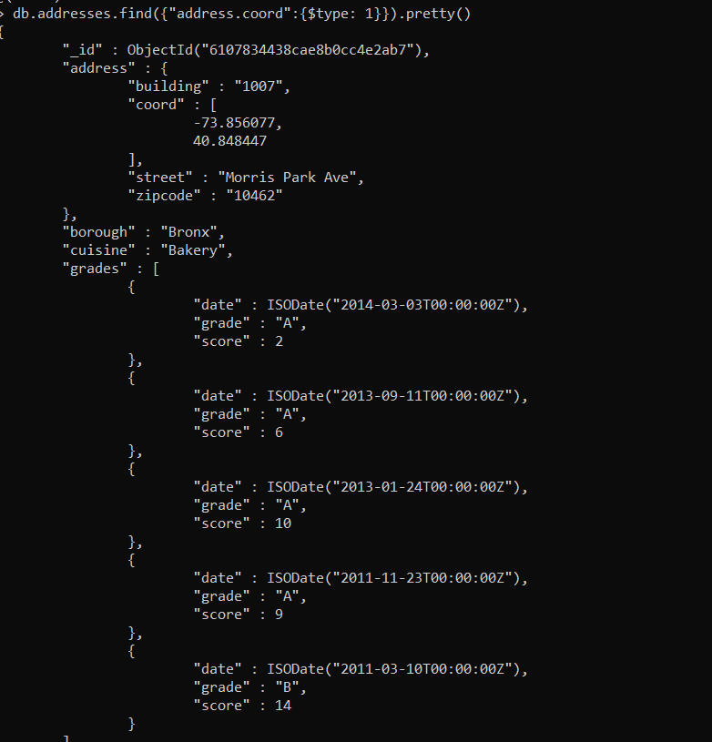

**30.**

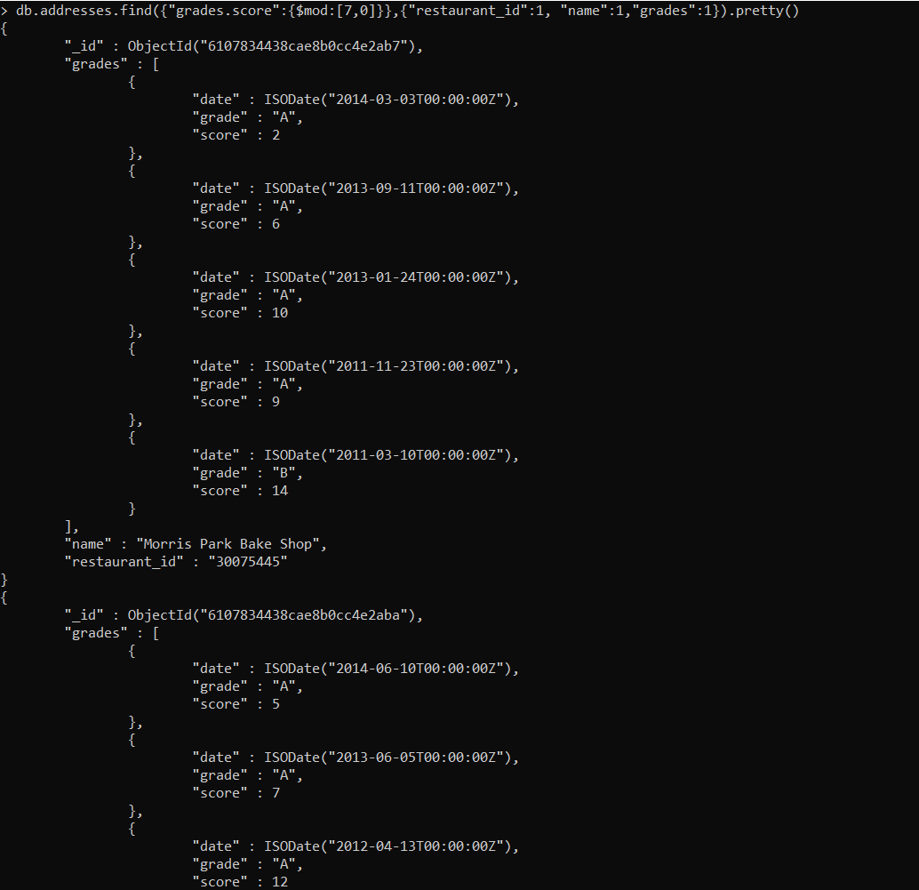

**31.**

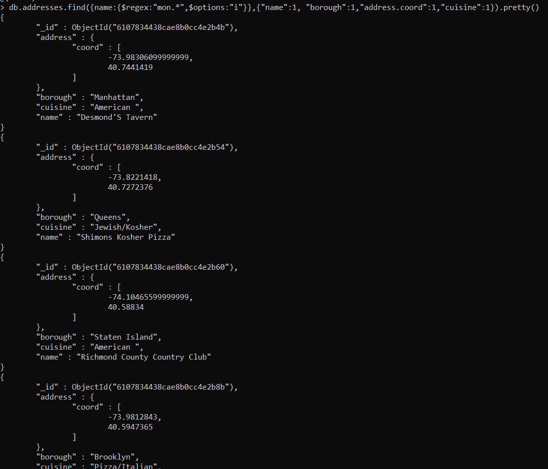

**32.**

